**SPRINT-4**

|  |  |
| --- | --- |
| Team ID | PNT2022TMID08806 |
| Project Name | Project – Hazardous Area Monitoring for Industrial Plant powered by IoT |

**WEB UI for Industrial owner and worker**

**Step-1:** Create a Sign up / Register page.

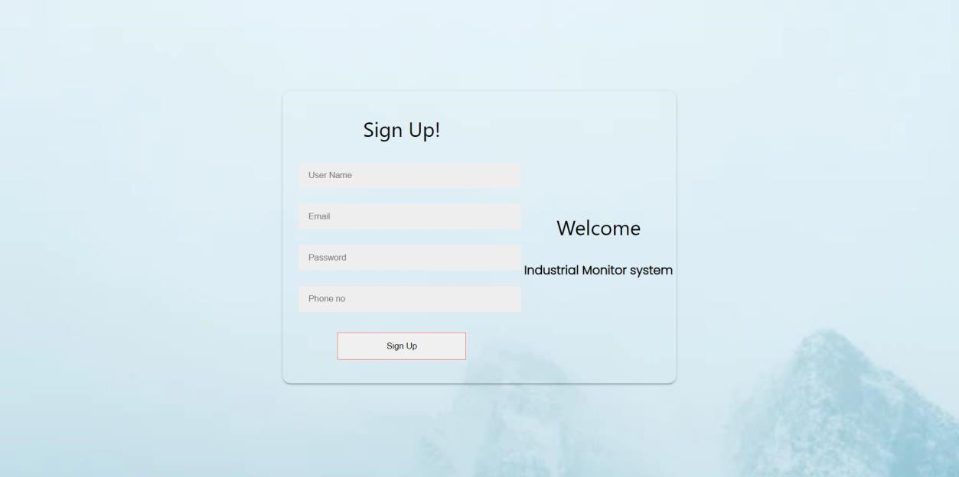

**Step-2:** Create a login page.

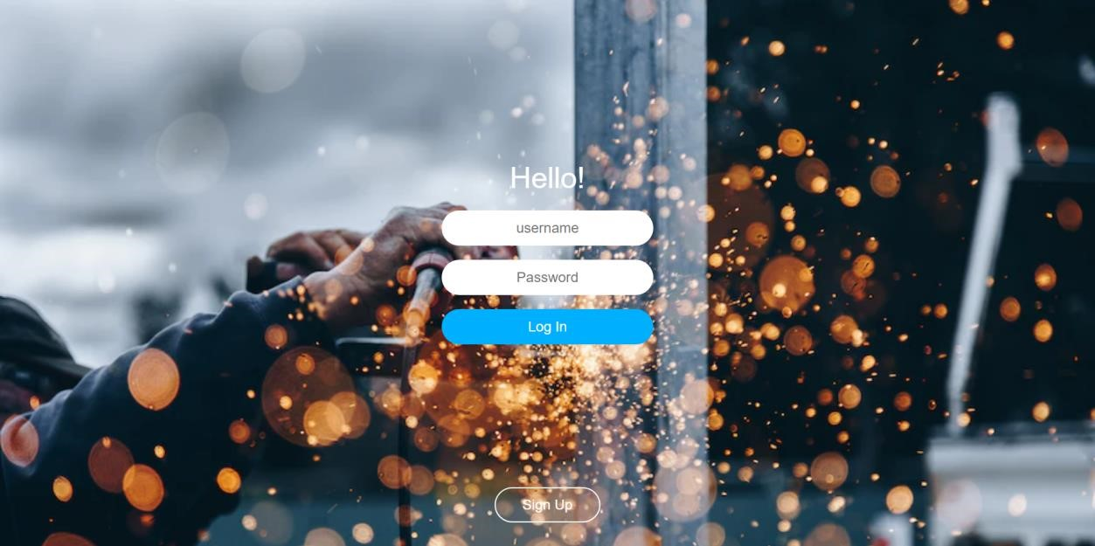

**Step-3:** After the login,It will be redirected to the Home Page.

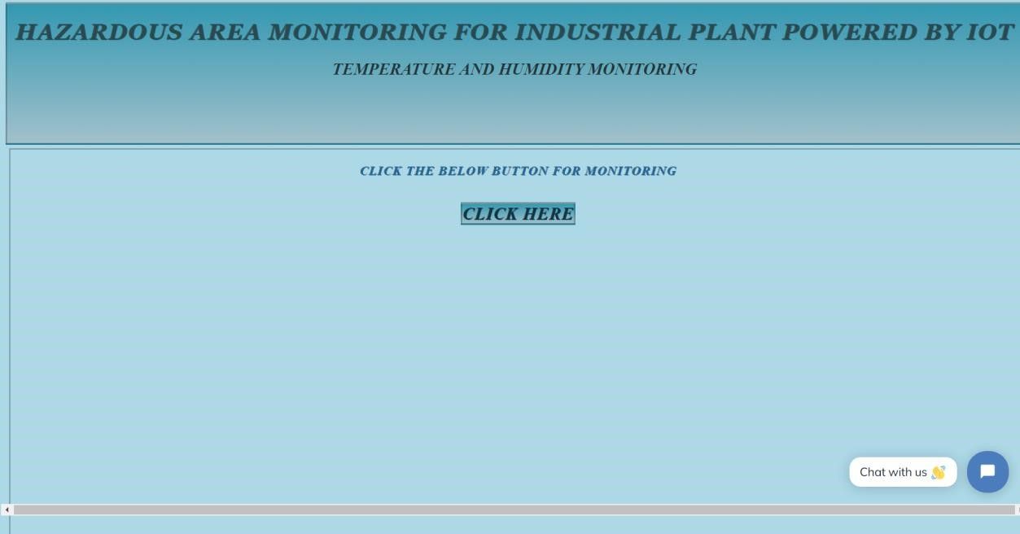

After clicking **CLICK HERE,**It will display the Temperature and humidity.

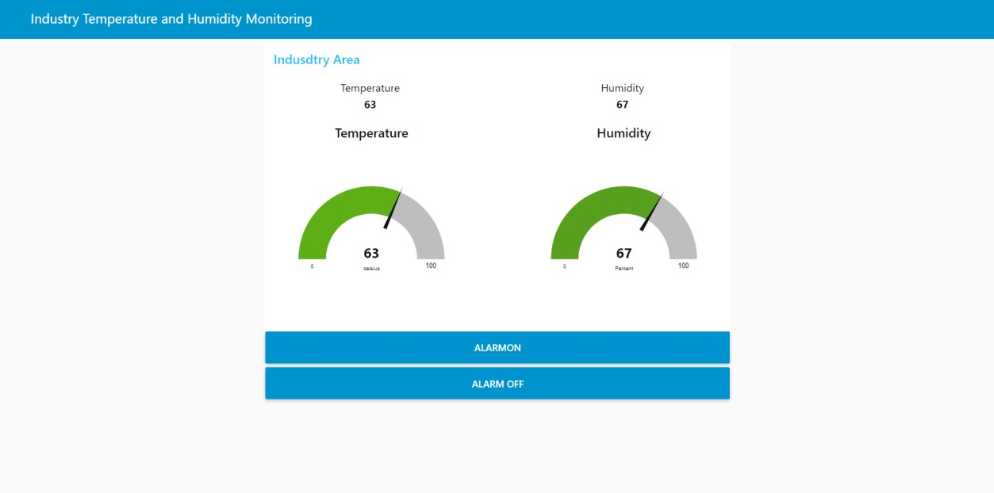

**Step-5:** Create a page with Industrial worker Info along with industrial where we can communicate with the industrial worker.

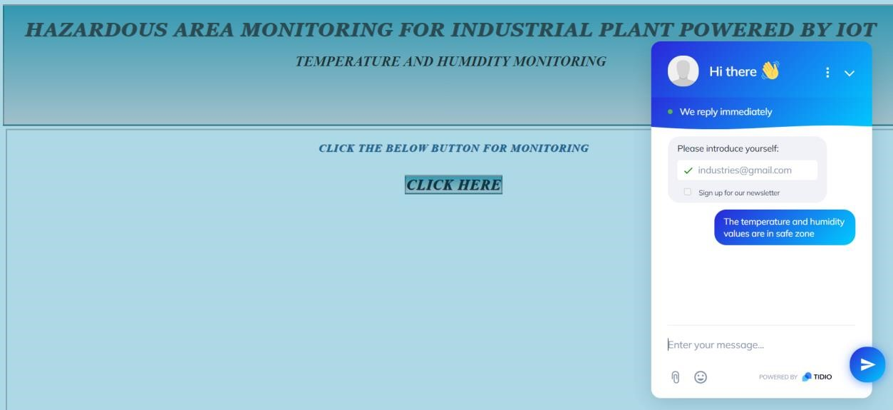

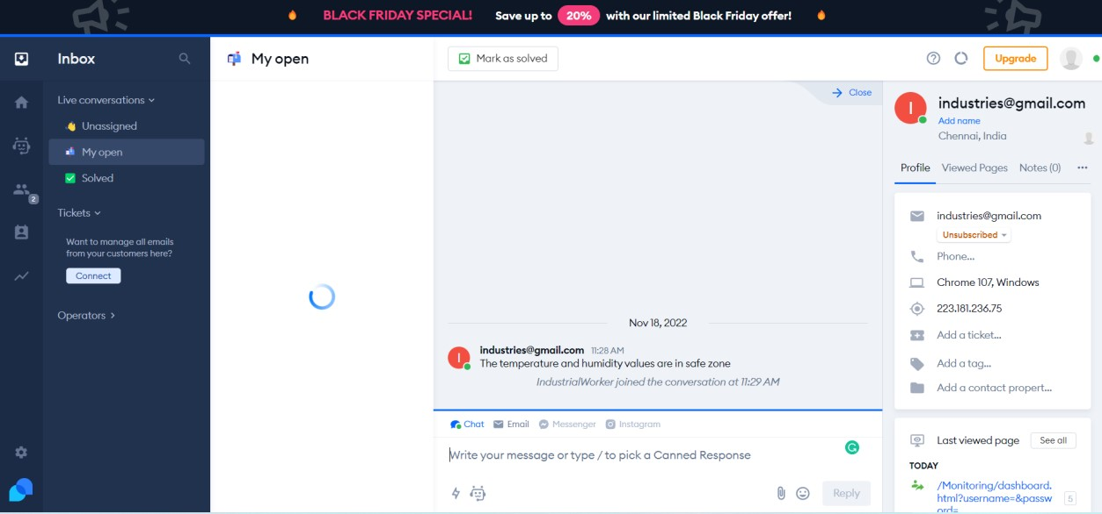

**Website Link**

<https://indusstrialmonitoringsystem.github.io/Monitoring/>